Q1: 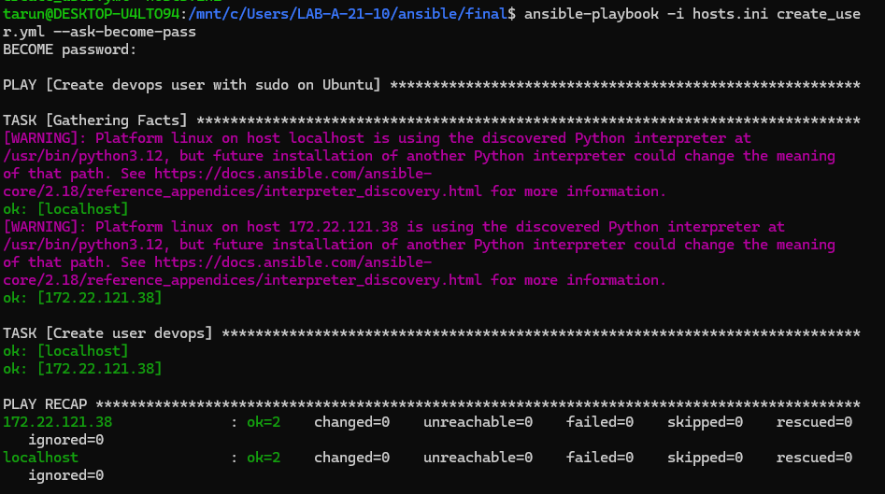
Q2: 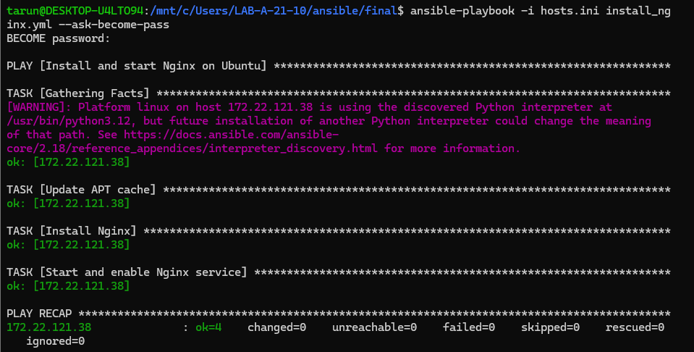
service check
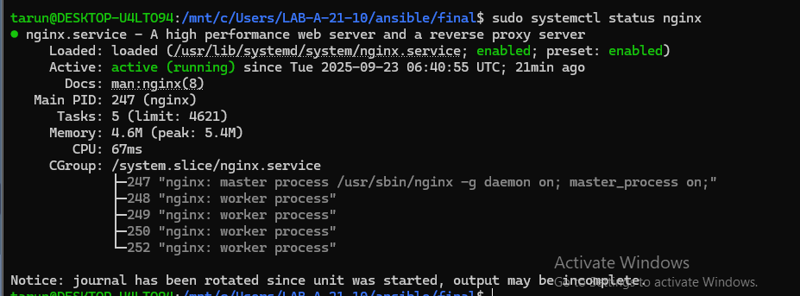
Q3
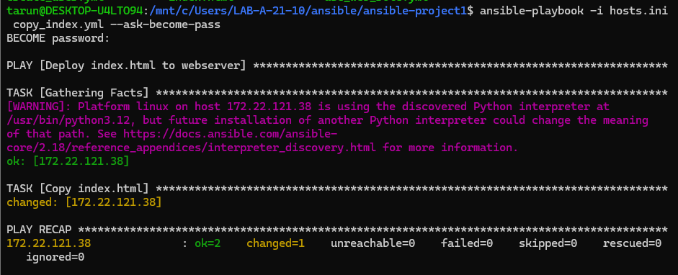

Q4:
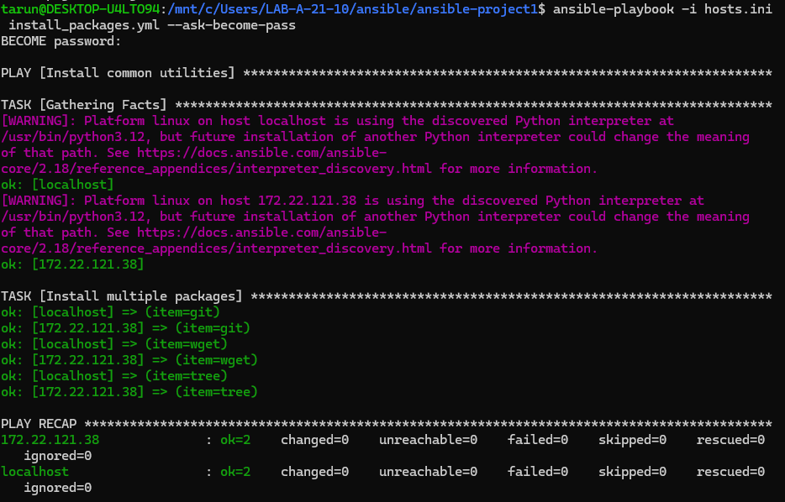
Q5
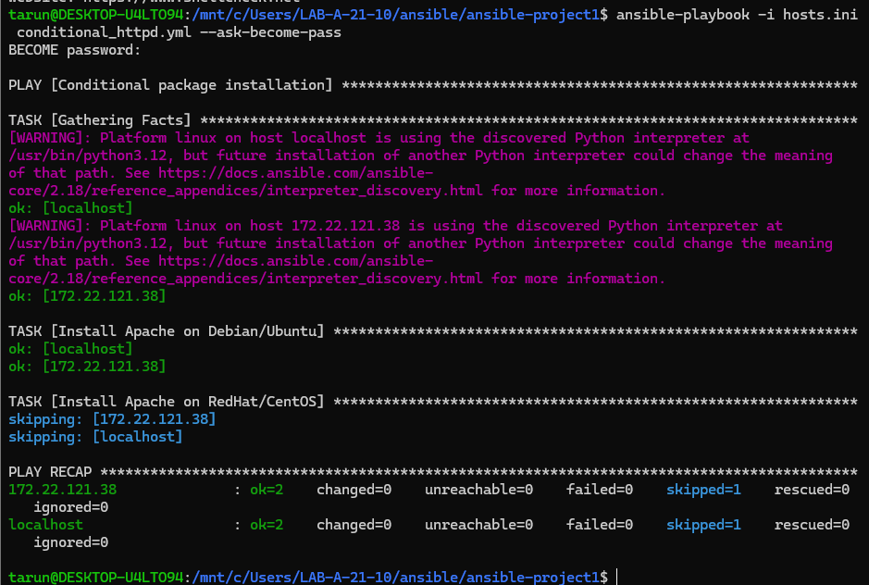

Q6:
Create apache2.conf
#C:\Users\LAB-A-21-10\ansible\final\apache2.conf
Listen 8080
ServerName localhost

# Minimal working Apache2 config
ServerRoot "/etc/apache2"
ServerName localhost

# PidFile
PidFile ${APACHE_PID_FILE}

# Timeout
Timeout 300
KeepAlive On
MaxKeepAliveRequests 100
KeepAliveTimeout 5

# Logging
ErrorLog ${APACHE_LOG_DIR}/error.log
LogLevel warn
CustomLog ${APACHE_LOG_DIR}/access.log combined

# Default document root
DocumentRoot /var/www/html

<Directory />
Options FollowSymLinks
AllowOverride None
Require all denied
</Directory>

<Directory /var/www/>
Options Indexes FollowSymLinks
AllowOverride None
Require all granted
</Directory>

# Include additional configs
IncludeOptional mods-enabled/*.load
IncludeOptional mods-enabled/*.conf
IncludeOptional conf-enabled/*.conf
IncludeOptional sites-enabled/*.conf

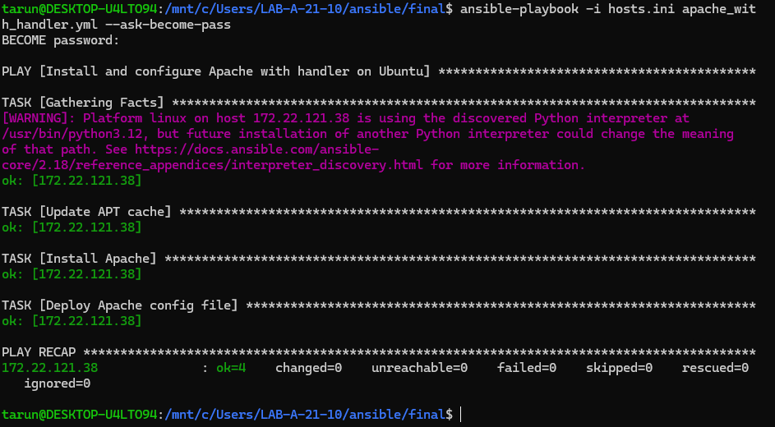
Note-first run apache_server.yml
Because:start server and check the server
Apcache2
:-sudo systemctl status apache2

Q7: 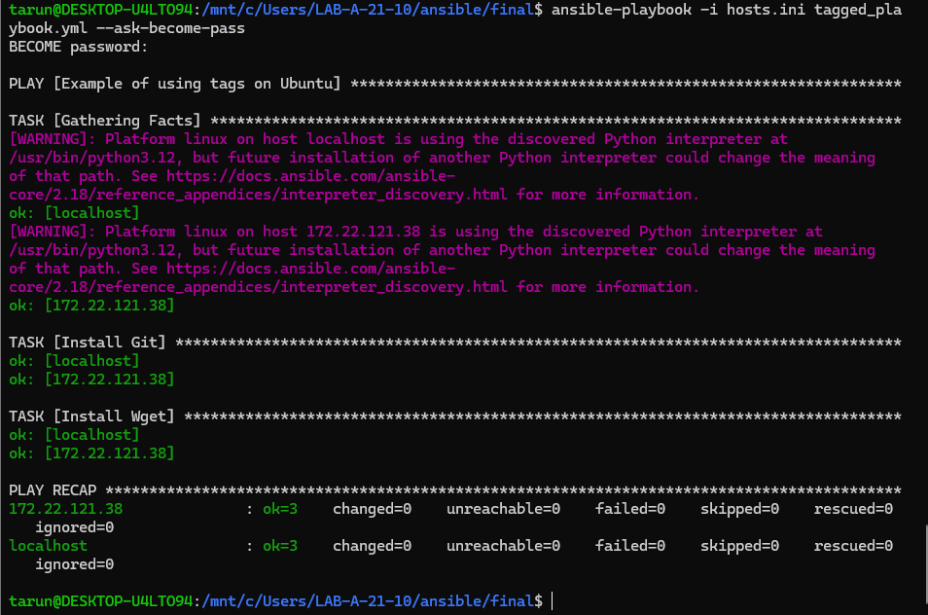
Q8:
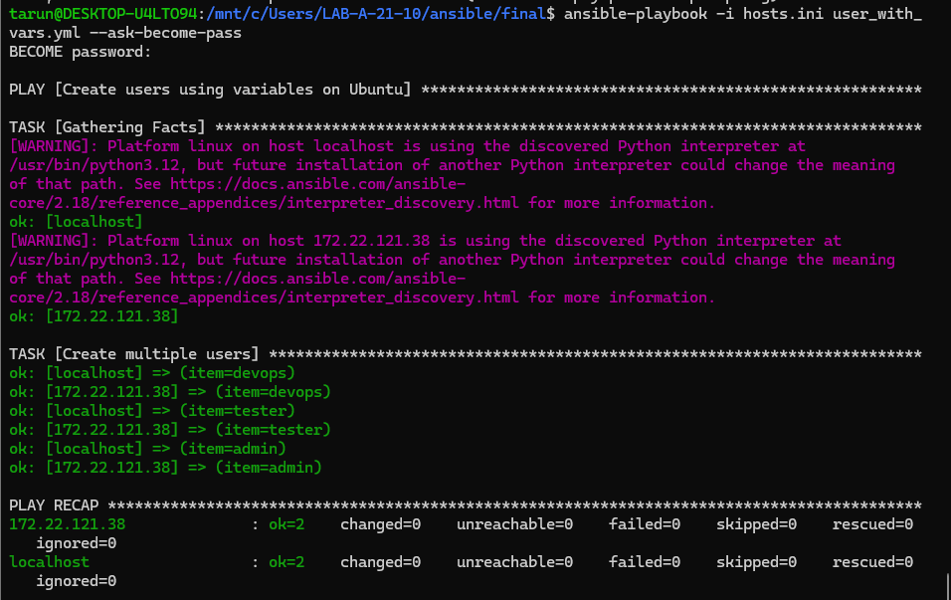

Q9:
Create role
Task:main.yml
--
# tasks file for roles/webserver

- name: Install Apache
apt:
name: apache2
state: present
update_cache: yes

- name: Ensure Apache is running
service:
name: apache2
state: started
enabled: yes

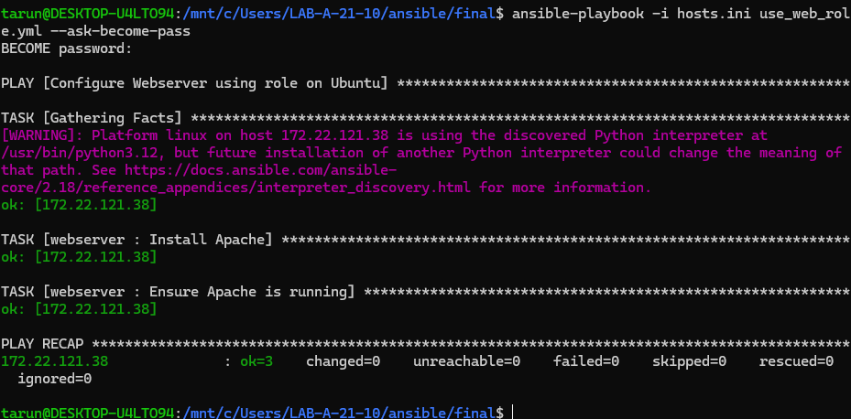
Q10:
